Lesson 02 Lesson-End Project

Configure Azure Active Directory

Project Agenda: To configure Azure Active Directory, and add and remove users from Azure AD

Description: You have been given a project to create Azure AD users in the subscriptions. Once the users have been created, you need to assign permissions to them.

Tools required: None

Prerequisites: None

Expected Deliverables: Add a screenshot showing the created Azure AD users and their assigned permissions

Steps to be followed:
- Create Azure AD users from the portal
- Assign permission to these AD users
- Delete the users from AD

Step 1: Create Azure AD users from the portal

- Sign in to the Azure portal as an administrator and select Azure Active Directory

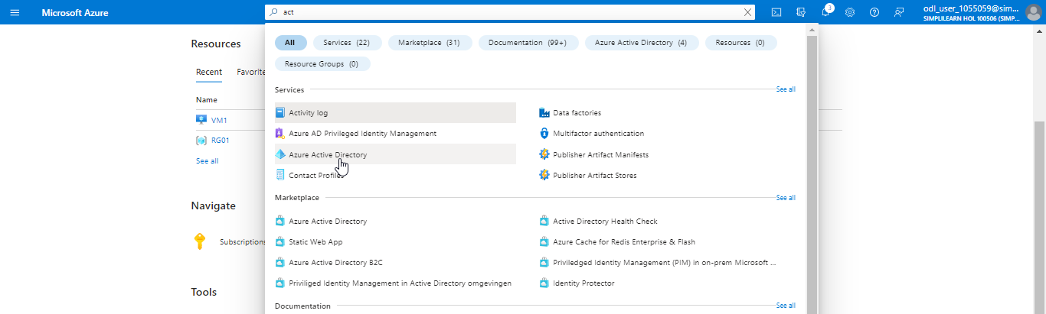

- Select Users

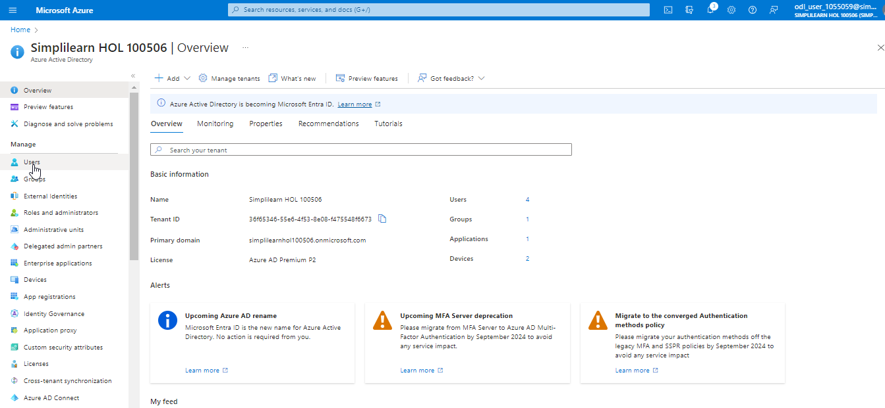

- Click on + New user and Create new user

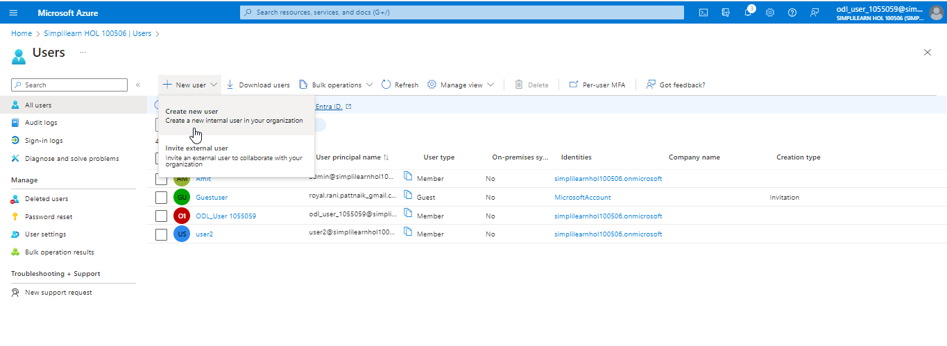

- Fill in the Basics and Properties tab and ensure you copy the auto-generated password provided in the Password section. You must enter this password to the user login into sign in for the first time.

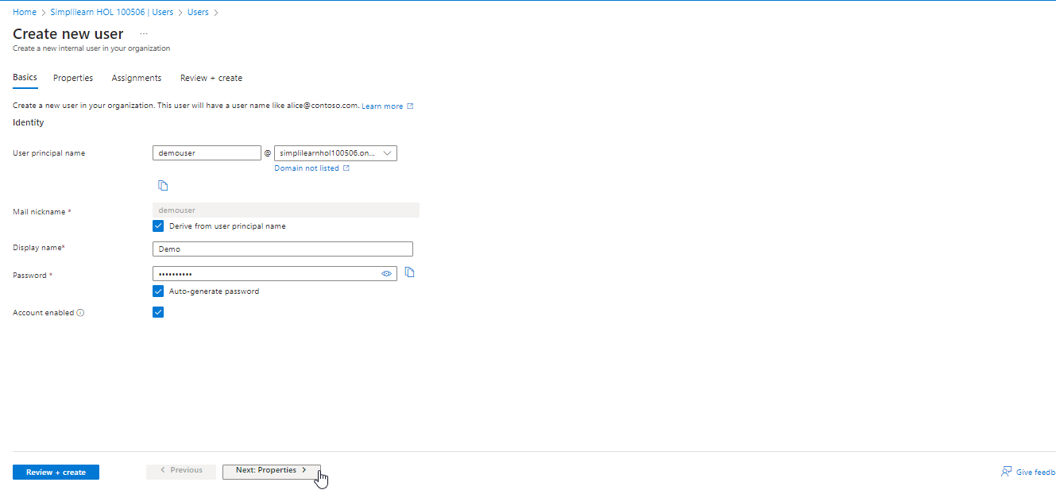

- Click on Next: Properties



- Click on Review + create

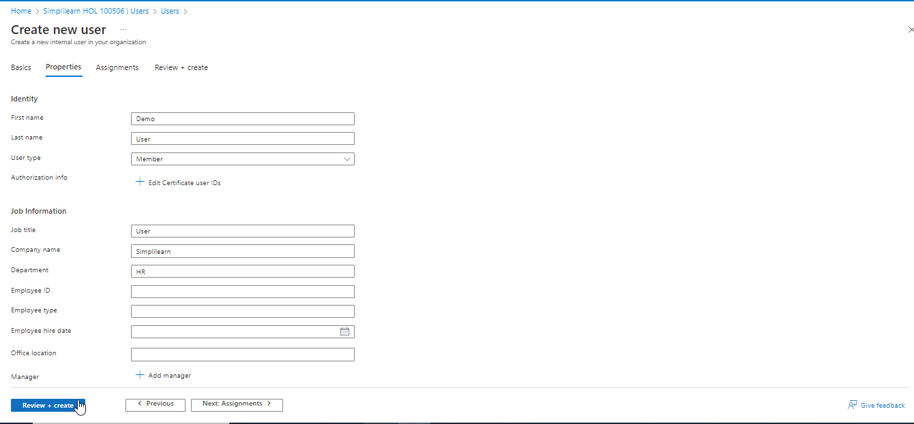

- Click on Create

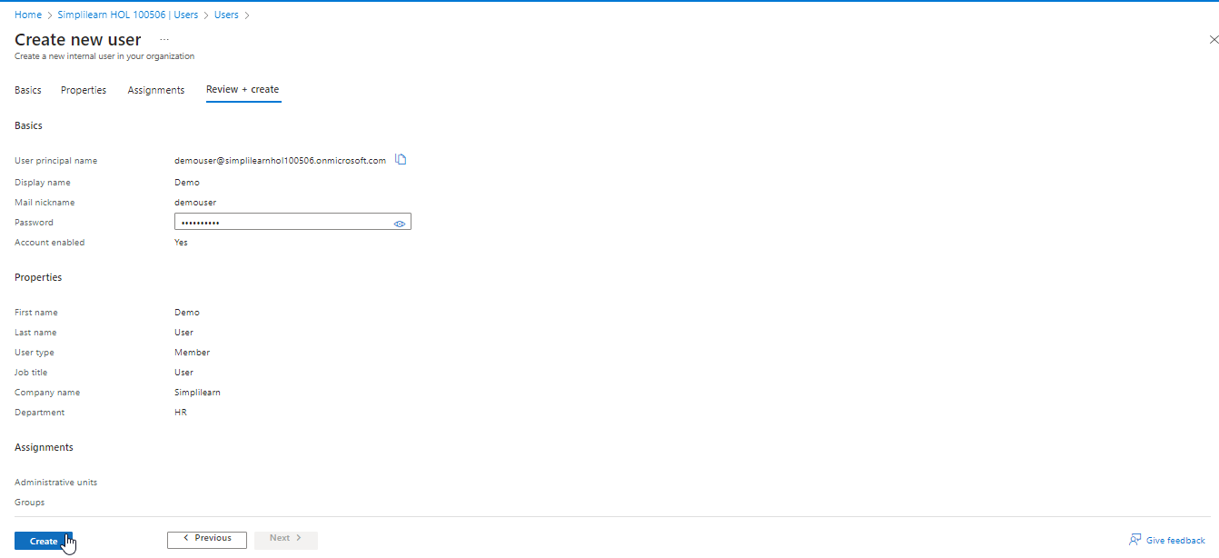

The output appears as follows:

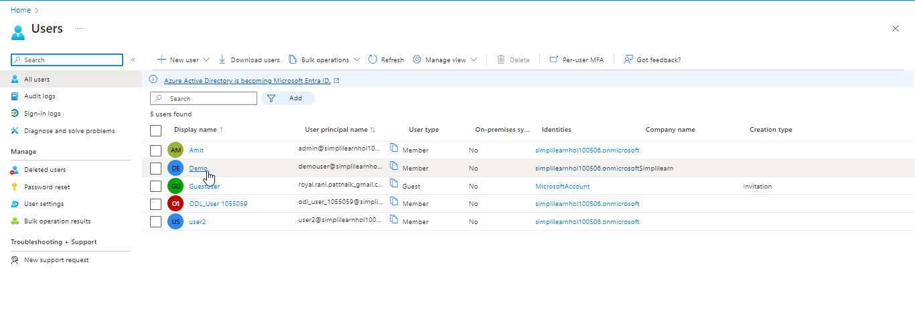

Step 2: Assign permission to these AD users

- Go to the Azure portal and search for and select Azure Active Directory

- Select Users and click on the newly created user (Demo)



- Click on Assigned roles

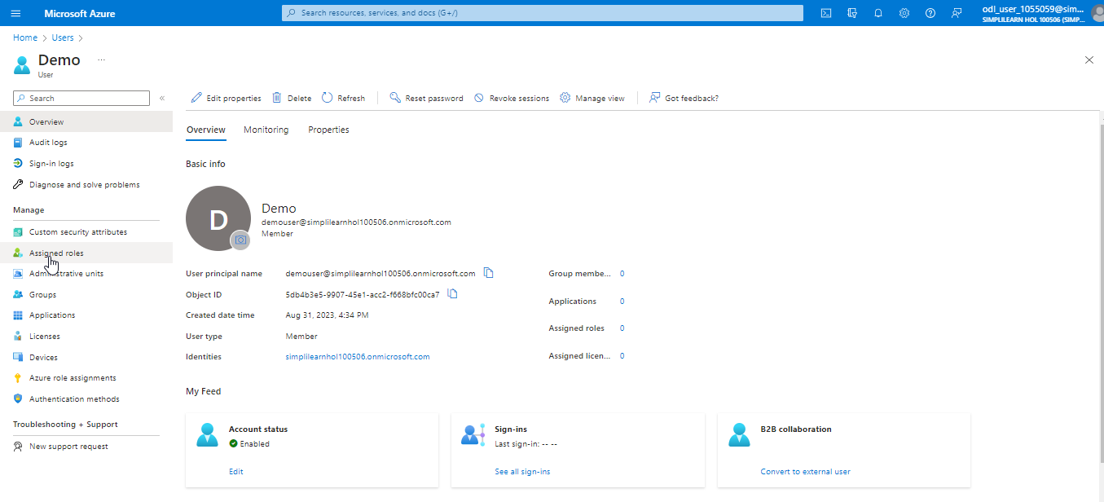

- Select Application Administrator under Directory roles and click on the Add button

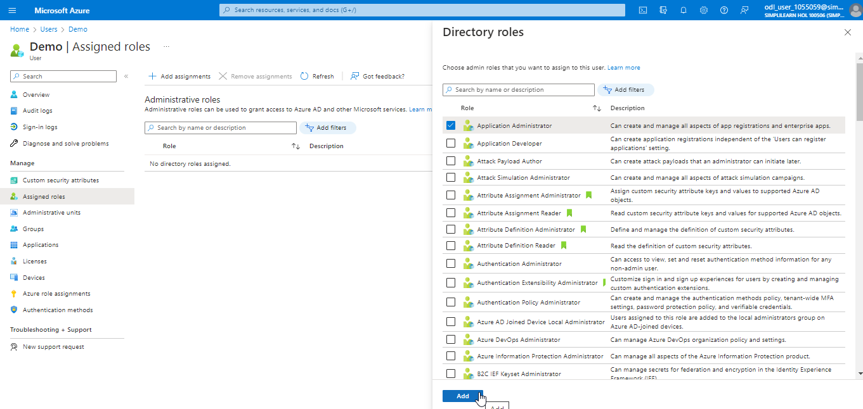

The output appears as follows:

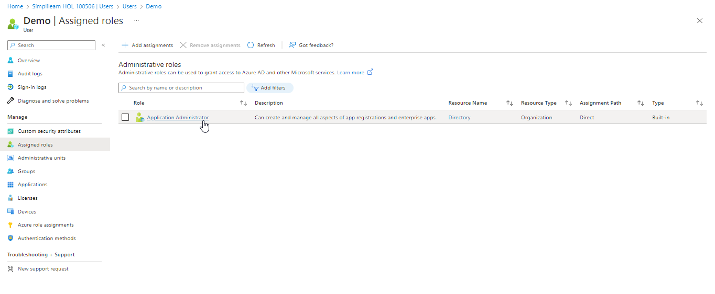

Step 3: Delete Azure AD users from the portal

- Sign in to the Azure portal using a user administrator account for the organization

- Search for and select Azure Active Directory from any page

- Search for and select the created user that the user wants to delete from the Azure AD

- Select Delete, and click OK

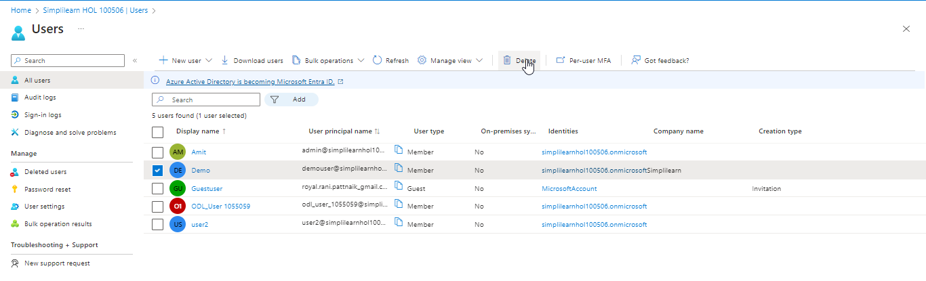

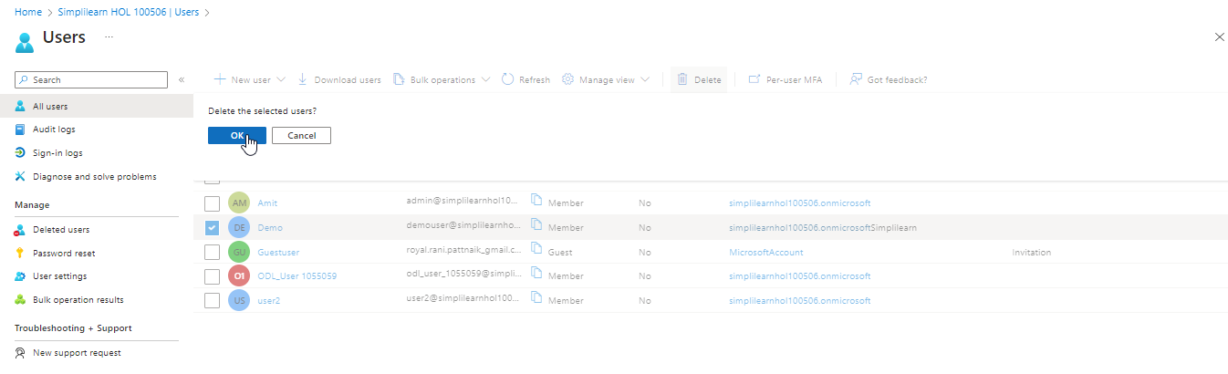

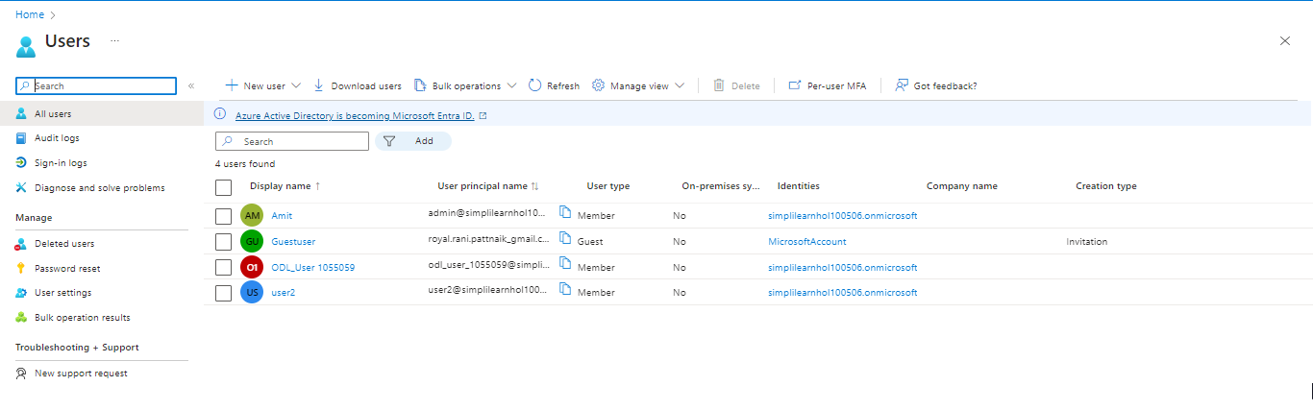

You have now successfully added users, assigned permission to them, and deleted them from the Azure directory.

